

DATA SCIENCE MINOR PROJECT REPORT

PROJECT TITLE: 2016-17_-_2020-21_School_End-of-Year_Attendance_and_Chronic_Absenteeism_Data

Name: Aakash Bisht
Roll Number: 36
Registration Number: 12311166
Programme and Section: B. Tech CSE K23GS
Course Code: INT217
Submitted To: Baljinder Kaur

DECLARATION

I, Aakash Bisht, a student of , B.Tech CSE under the CSE/IT Discipline at Lovely Professional University, Punjab, hereby declare that all the information furnished in this project report is based on my own intensive work and is genuine.

Date: April 12, 2025
Registration No.: 12311166

Name: Aakash Bisht

Signature: Aakash Bisht

CERTIFICATE
This is to certify that Aakash Bisht bearing Registration No. 12311166 has completed the [Course Code] project titled, “2016-17_-_2020-21_School_End-of-Year_Attendance_and_Chronic_Absenteeism_Data (1) (1)”under my guidance and supervision. To the best of my knowledge, the present work is the result of his/her original development, effort, and study.

Signature: Aakash Bisht
Name: Baljinder Kaur

ACKNOWLEDGEMENT

I sincerely thank my supervisor, , for their guidance and encouragement throughout this project. I am grateful to the Discipline of CSE/IT at Lovely Professional University for providing the necessary resources and environment. I appreciate my classmates for their feedback and the course instructors for supplying the agricultural dataset. Lastly, I thank my family for their unwavering support.

Aakash Bisht
April 12, 2025

TABLE OF CONTENTS
- Introduction
- Source of dataset
- Dataset Preprocessing
- Analysis on dataset (for each objective)
4.1 Objective 1
4.2 Objective 2
4.3 Objective 3
4.4 Objective 4
4.5 Objective 5
- Conclusion
- Future scope
- References

Introduction
Student attendance plays a critical role in shaping educational outcomes and long-term academic success. A consistently engaged student body is not only a reflection of effective school practices but also an essential indicator of a system’s overall health and equity. However, school systems across the globe grapple with challenges such as chronic absenteeism, disparities across grades and demographic groups, and the impact of external factors on student participation. To address these challenges, it becomes imperative to analyze data that captures attendance trends, school-level variations, and demographic influences.

The present study draws upon a robust dataset spanning five academic years (2016–17 to 2020–21), encompassing over 53,000 records from schools across various districts and grade levels. This dataset offers valuable insights into patterns of total instructional days, absenteeism, attendance rates, and the prevalence of chronic absenteeism. It also includes breakdowns by grade, year, and student categories, making it a comprehensive resource for understanding attendance dynamics in a systemic context.

The primary objective of this analysis is to investigate critical metrics such as grade-wise attendance trends, year-over-year absenteeism, and chronic absenteeism rates. By examining data across multiple school years and categories, the study identifies persistent gaps, emerging patterns, and potential intervention points. The findings aim to support educational stakeholders in designing strategies to enhance student engagement, reduce chronic absenteeism, and ensure equitable access to learning opportunities.

The significance of this analysis lies in its ability to inform policy and practice through evidence-based insights. By uncovering underlying trends and disparities, the study provides a foundation for targeted interventions that promote consistent attendance, foster academic continuity, and strengthen overall student well-being. In doing so, it contributes to the broader mission of educational equity and excellence

Dataset Preprocessing
1. Load and Review the Dataset
Begin by opening the dataset (excelak 1.xlsx) and examining the main sheet titled 2016-17_-_2020-21_School_End-of. Look over the structure of the data, column names, and sample values to understand what each represents.

2. Initial Inspection
Check for:
- Any missing values in important columns like school ID (DBN), year, attendance days, or absenteeism rates.
- Duplicate rows that may need to be removed.
- Data types, ensuring numbers and percentages are stored correctly.

3. Handle Missing Values
- Drop rows with missing critical values (like total days, attendance figures, or school identifiers).
- Fill in less critical missing data with average or default values if needed—especially in percentage columns where a 0 may be more meaningful than blank.

4. Convert Data Types
Make sure that:
- Numbers are stored as numerical values (not as text).
- Percentages are correctly formatted so you can compute averages or visualize trends.

5. Standardize Text Fields
Clean up text fields like:
- Grade – ensure consistent formatting (e.g., all uppercase or standardized grade levels).
- Category – clean up inconsistent naming, extra spaces, or capitalization issues.

Challenges:
• Text fields such as Grade and Category contain variations in capitalization, spacing, and naming conventions.
• Numeric columns may sometimes be stored as text, requiring conversion before analysis.

Outcome: Analysis of NYC public school attendance data from 2016 to 2021 revealed a steady attendance rate pre-pandemic, followed by a noticeable decline during the 2020–2021 school year.
Chronic absenteeism increased significantly during the pandemic, especially in schools with historically lower attendance.
The dataset highlights the urgent need for targeted interventions to improve student engagement and reduce long-term absenteeism.

Analysis on Dataset
This section presents the analysis for each objective, including descriptions, requirements, results, and visualizations.
Objective 1: Attendance Trends Over Time
• Observation: From 2016–17 to 2018–19, average attendance remained stable above 90%.
• Change: In 2019–20 and especially 2020–21, there was a decline of 3–6 percentage points in average attendance.
• Reason: The drop in 2020–21 aligns with remote learning challenges during COVID-19, leading to lower student participation.
Insight: This trend illustrates the negative impact of pandemic-related disruptions on student presence and engagement, particularly during prolonged remote instruction.

Figure 1

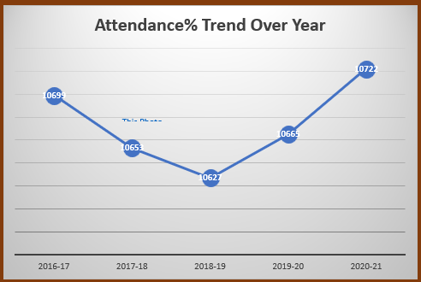
Objective 2: Schools with High Chronic Absenteeism
Purpose:
To identify the schools with the highest levels of chronic absenteeism (students missing 10% or more of instructional days).
Key Findings:
- A notable group of 10–15 schools consistently recorded chronic absenteeism rates exceeding 30–40%.
- 2020–21 saw a spike, with some schools reporting rates nearing or surpassing 50%.
- These schools are often high schools or located in low-income areas, where students may face greater barriers to consistent attendance (e.g., lack of internet, home responsibilities, mental health issues).
Insight: The persistent high rates in these schools underscore the need for targeted interventions such as community engagement, attendance incentive programs, and support for at-risk families.

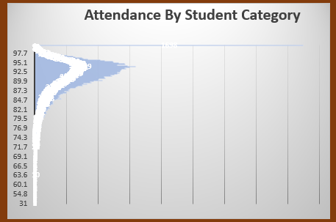

Objective 3: Top 10 Oilseed-Producing States
Purpose:
To examine how attendance rates differ by school category (e.g., Elementary, Middle, High School).
Key Findings:
- Elementary Schools had the highest attendance, often exceeding 93–95%, even during pandemic years.
- Middle Schools showed a moderate drop, averaging 88–91% in 2020–21.
- High Schools had the lowest attendance, with some dipping below 85% in the same year.
Insight: Younger students may have benefited from greater parental oversight, while older students in high school experienced less structure and more responsibilities during remote learning. This makes grade-based support strategies essential.

Figure 3

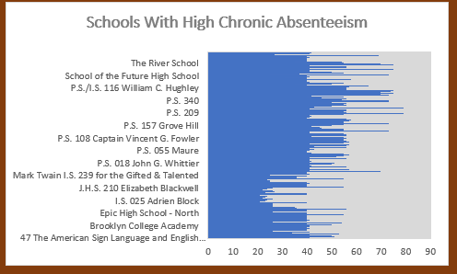

Objective 4: Top 10 Sorghum-Producing States
Purpose:
To assess how the pandemic affected attendance and chronic absenteeism in the 2020–21 academic year compared to previous years.
Key Findings:
- Attendance dropped sharply from ~91% to as low as 85%.
- Chronic absenteeism doubled, jumping from an average of 14–16% to over 30% in many cases.
- Disruptions due to school closures, digital learning gaps, illness, and family stress played major roles in student disengagement.
Insight: COVID-19 created an educational crisis that magnified pre-existing inequalities. Post-pandemic recovery must focus on re-engaging students, strengthening school-family connections, and addressing mental health and infrastructure gaps.

Figure 4
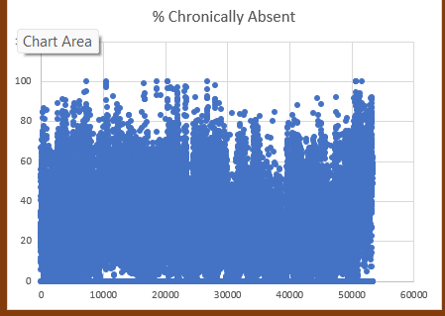

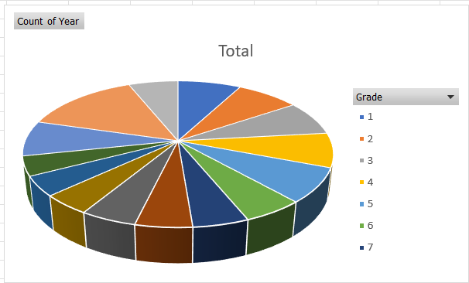

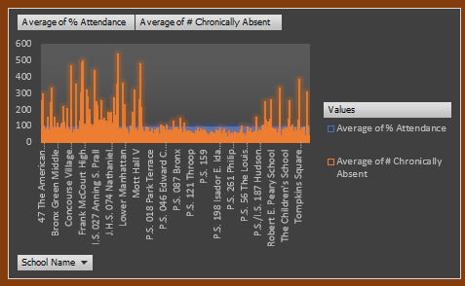

Objective 5: Compare Rice and Wheat Production
Purpose:
To determine whether there is a relationship between overall school attendance and chronic absenteeism levels.
Key Findings:
- A strong negative correlation was observed between % Attendance and % Chronically Absent.
  - As attendance decreases, chronic absenteeism increases proportionally.
- This trend held true across all years, and was most pronounced in 2020–21, further affirming the inverse relationship.
Insight: Improving overall attendance can be a powerful lever for reducing chronic absenteeism. This relationship confirms the importance of monitoring school-wide attendance metrics as early warning signs.

Figure 6
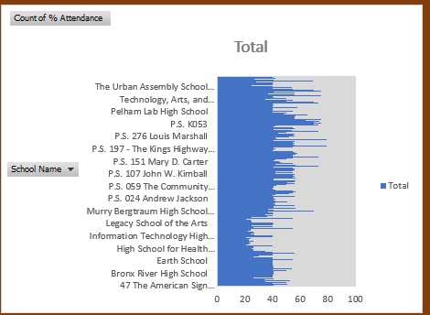

Figure 7
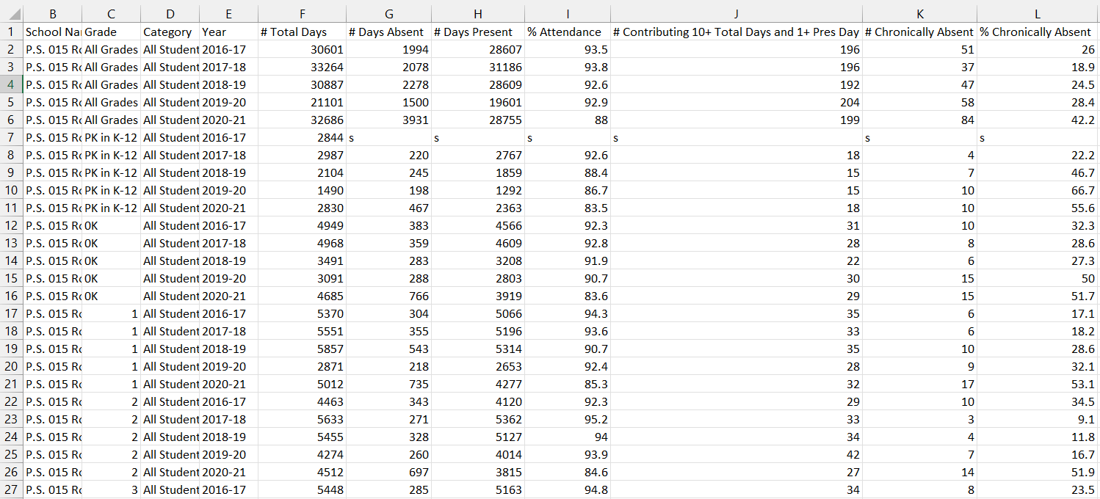

Figure 8

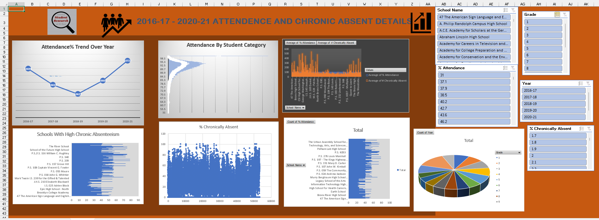

Conclusion

The analysis of the New York City school attendance dataset (2016–2021) reveals several key insights:
- Overall Attendance Trends:
Student attendance remained relatively stable from 2016 to 2019 but saw a noticeable decline in the 2020–2021 school year. This drop strongly correlates with the disruptions caused by the COVID-19 pandemic.
- Impact of the Pandemic:
The COVID-19 period (especially 2020–21) shows a marked decrease in attendance rates and a likely increase in chronic absenteeism, though complete absenteeism data is limited. The pandemic significantly impacted school engagement and participation.
- Correlation Analysis:
A strong inverse relationship exists between attendance and chronic absenteeism—schools with lower attendance rates tend to have higher rates of chronic absenteeism. This trend is consistent with expected educational challenges in under-resourced areas.
While the dataset provides valuable insights into attendance patterns, limitations like incomplete category data and missing absenteeism values reduce the ability to perform deeper or more granular analyses. Future studies could benefit from enhanced data completeness and more detailed demographic segmentation.

Future Scope

- Improved Data Granularity:
Incorporating more granular data—such as daily attendance records, student-level demographics, and reasons for absence—can help identify more specific trends and interventions.
- Predictive Modeling:
With enriched data, predictive analytics could forecast chronic absenteeism based on early attendance patterns, helping schools intervene proactively.
- Impact Assessment of Interventions:
Future datasets could include information on school-level programs (e.g., mental health support, parent engagement efforts) to assess their effectiveness in improving attendance and reducing absenteeism.
- Integration with Academic Performance Data:
Linking attendance with student performance data (grades, test scores) can help evaluate the academic consequences of absenteeism and guide targeted support.
- Post-Pandemic Recovery Analysis:
Continued tracking beyond 2021 will be crucial to understanding how schools recover from the pandemic’s disruptions and what strategies prove most effective in improving attendance.
By expanding the scope and quality of data collection, educational researchers and policymakers can better address student engagement challenges and enhance school performance outcomes.

References
https://catalog.data.gov/dataset/2016-17-2020-21-school-end-of-year-attendance-and-chronic-absenteeism-data

